Student’s Name
Instructor’s Name
Course
Date
Opportunities and Challenges in the Canada Construction Industry
The construction industry in Canada is one of the most competitive sectors and contributes to 7 % of the GDP of Canada (Atkins, 234). The industry offers both challenges and opportunities to entrepreneurs. The industry deals with the construction of factories, shopping centers, hospitals, houses, skyscrapers, nuclear power stations, highways, petrochemical plants et cetera. The construction industry is both a service industry and production industry.it is considered as a service industry because it carries out work in response to the investment decisions of others, similarly it is considered as a production industry because it provides physical means for industrial development and shelter. The construction process involves different functions this includes arranging project financing, acquiring the necessary site for construction, etc. Single and multiple dwellings form the largest part of the construction industry.
The design team in the construction industries includes the following personnel; construction managers, engineers, painters, plumbers, electricians, heavy machine operators, bricklayers, and vehicle operators, thus there is a large number of people benefiting from the construction industry. This report will focus on opportunities provided by the construction industry and challenges facing the industry. Before highlighting opportunities and challenges in any industry it is important to know about the trend of the industry. The construction industry in Canada performed poorly in 2015 and has shown strong performance in the last 4 years. The weak performance was associated with low commodity prices, high unemployment rates, and weak economic conditions. The strong performance is due to an increase in commercial projects as well as an increase in investment in both the private and public sectors.
The growth of employment in the construction industries has increased by 80% in the last fifteen years. According to BuildForce Canada, the construction industry will create 12000 jobs in residential construction and 52000 jobs in the non-residential sector by 2023. Currently the commercial, residential and infrastructure constructors employ over 1.2 million people.Besides the Ontario construction industry has about 600,000 employees.
Construction in Canada is mainly driven by urbanization and population growth. (Black,36).High population growth in Canada creates opportunities in the construction industry. According to the census, the number of people aged sixty-five years and above is likely to increase in the coming years. This will create the need for hospital and retirement facilities. Similarly, the need for schools is likely to increase by 8% during the same period. Besides, the increased population will create the need for residential houses. Additionally, the government plans to spend massively on social infrastructure by 2020 through the affordable housing program and renovation. The government's major infrastructure program is likely to support expansion in the construction industry in the forecast years.
The Canadian government is focused on innovation and skills. The government is determined to make Canada a leading center for innovation and targets areas such as digital industries and infrastructure. “The innovation and skill plan” is a governmental policy announced during the Canadian government’s budget 2017 and aims to provide Canadians with future digital-proofing tools and skills. The government support offered in this plan is likely to boost the construction industries by creating numerous opportunities. Additionally, the construction stakeholders are opting for time-saving and innovative technological solutions to cater to wider opportunities presented by the industry both locally and globally.
In 2016 the Ontario government announced its plan to invest massively in large scale construction projects by 2025. This is expected to create opportunities as well as supporting the country's construction industry in the coming years. Similarly, in 2017, the Canadian government announced plans to launch an infrastructure bank to support the countries construction projects. The infrastructure bank will work in collaboration with the territorial, provincial and municipal governments to construct port, roads, energy transmission lines, water treatment plants and railway corridors. Additionally, according to Statistics Canada, the number of residential building permits has increased rapidly in the last 3 years. The above projects have created massive opportunities in the construction industry.
In 2018 the residential buildings were the largest in the Canadian construction market. In the 2019 budget the Canadian government plan to spend over US$ 943.0 M to provide financial help to first-time homeowners during 2019-2022, this is expected to support growth in the industry. The industry is expected to reach US$ 304.6 billion by 2023.

Canadian construction industry
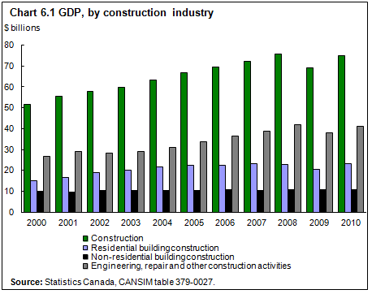
Like any other sector construction industry in Canada is faced with several challenges. Firstly the Canadian population is composed of aging people and lacks diversity. In 2018 the BuildForce Canada reported that over 250,000 construction employees plan to retire this decade thus attracting and maintaining the next generation of construction employees is a key priority. Indigenous workers and females represent 4 % of the skilled construction employees thus construction stakeholders should focus on ensuring construction workplaces are safe and flexible to attract a large workforce. Today the Canadian construction market is not attracting enough talents to meet the growing demand. A survey conducted in 2018 found that 80 % of construction companies are finding trouble in hiring qualified employees.
Another problem facing the Canadian construction industry is the fact that industry productivity growth is highly cyclical, recognized as a vicious productivity cycle. During low economic activities, firms that invest in capital and innovation are vulnerable. During such time construction stakeholders are reluctant to invest in new technologies, innovation, and processes leading to growth in other sectors. This includes construction management software and modern construction methods such as offsite manufacture.
Productivity in Canada also varies geographically by state or province. Besides it also varies within the industry itself, some of the industries record high productivity than others. The presence of these geopolitical challenges limits growth in the construction industries thus lowering the total output. Besides the construction industry is facing competition from other global construction companies, thus companies must evolve and leverage information technology to remain at the top of the competition.
Construction industries are reluctant to adopt new technologies. This is a major challenge facing the Canadian construction industry. Researches show that construction entrepreneurs continue to underinvest in technology despite acknowledging the benefits of technology in undertaking and managing construction projects. New technologies are important for any sector to record significant growth. Emerging technologies such as robots, 3D printing and drones are being used in the construction industry. Similarly, industries are adopting self-driven vehicles to address the issue of truck drivers’ shortage.This will ensure the industry remains at the top of the competition. It is predicted that companies adopting new technology will have a noticeable advantage over others.
Legislations governing the construction industries are not standard. An inspector in one region says one thing and another in another region says something different. For example, getting environmental approval in Ontario you have to walk with all kinds of binders to get signs for different consultants. You need 100 construction permits in Ontario but only 4 permits in Manitoba. The environmental bodies have been reluctant in setting up standard rules in all regions. For example, one would wonder why the bald eagle is an endangered species in Canada but no longer an endangered species in the United States. The residential construction council of Ontario should streamline the approval process to cut down the total time taken to kick start a project. They should consider electronic binding as opposed to the physical stuff.
Employees’ safety is another challenge facing the Canadian construction industry. For many decades the construction industry has led all sectors in the total number of employee deaths. Keeping workers safe should be a top priority for all stakeholders in the construction industry. The total time taken away from work after an injury is approximately 10 days thus the amount of productivity lost due to illness and injuries is significant. All stakeholders in the construction industry should join hands and emphasize safe working practices; this will improve the industry's reputation as well as ensuring higher productivity. 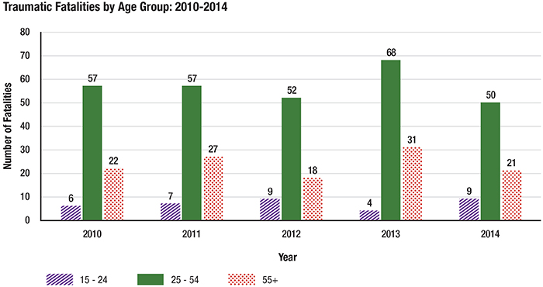

The table below shows the comparison of the accidents that happened in constructions among different countries.
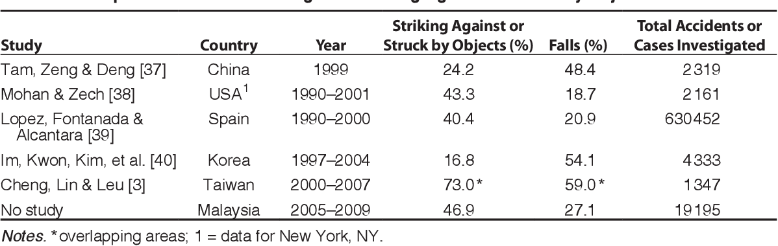
In conclusion, every industry has its opportunities and challenges. In Canada and Ontario, the construction industry is the most competitive and contributes 7% of the country’s GDP. The industry deals with the construction of houses to skyscrapers, power plants, highways, railways both locally and globally. Residential buildings are the largest Canadian construction market. Labor shortages and the aging population are some of the major challenges facing the industry. Over 250000 workers are planning to retire in the coming years leaving a workforce gap. Additionally, the industry growth occurs at regular intervals and sometimes it is unpredictable. Construction entrepreneurs are also reluctant to adopt new technologies that are important for the success of any company in the 21st century. Employee safety is another problem facing the construction industry. Safety should be the priority in the construction industry. The government should also standardize legislation governing the construction industry to reduce the total time taken to start a project.
References
Industrialization in Building Construction. National Research Council of Canada, 2009.
Black, W. D. Construction. [Canadian Construction Association?], 1934.
The Canadian Constructor Worldwide. The Corporation = La Corporation, 2007.

